# **IIT Kanpur Intensive Training School (ITS) on PYTHON for Machine Learning, Neural Networks and Deep Learning**

# **2nd to 22nd December 2023**

**Assignment #2**

1. The centroid of the $i$ th cluster in $l$ th iteration, denoted by ${\overline{μ}}_{i}^{\left(l\right)}$, is

$\frac{\sum_{j=1}^{M}{α_{i}^{\left(l\right)}\left(j\right)\overline{x}\left(j\right)}}{M}$

$\frac{\sum_{j=1}^{M}{\overline{x}\left(j\right)}}{M}$

$\frac{\sum_{j=1}^{M}{\overline{x}\left(j\right)}}{\sum_{j=1}^{M}{α_{i}^{\left(l\right)}\left(j\right)}}$

$\frac{\sum_{j=1}^{M}{α_{i}^{\left(l\right)}\left(j\right)\overline{x}\left(j\right)}}{\sum_{j=1}^{M}{α_{i}^{\left(l\right)}\left(j\right)}}$

Ans

1. The **entropy $H\left(X\right)$** of a source is defined as

$-\sum_{i=1}^{n}{p\left(x_{i}\right)\log_{2}{\frac{1}{p\left(x_{i}\right)}}}$

$\sum_{i=1}^{n}{\frac{1}{p\left(x_{i}\right)}\log_{2}{\frac{1}{p\left(x_{i}\right)}}}$

$-\sum_{i=1}^{n}{\frac{1}{p\left(x_{i}\right)}\log_{2}{\frac{1}{p\left(x_{i}\right)}}}$

$\sum_{i=1}^{n}{p\left(x_{i}\right)\log_{2}{\frac{1}{p\left(x_{i}\right)}}}$

Ans

1. Consider the table below showing ***joint probabilities*** of

$$X=\left\{IC,\overline{IC}\right\}, Y=\{CHOC, \overline{CHOC}\}$$

|  |  |  |
| --- | --- | --- |
|  | $$IC$$ | $\overline{IC}$ |
| $$CHOC$$ | $$\frac{1}{6}$$ | $$\frac{1}{3}$$ |
| $$\overline{CHOC}$$ | $$\frac{1}{6}$$ | $$\frac{1}{3}$$ |

The quantity $H\left(Y|X=\overline{IC}\right)$ is given as

* 1. 0.92
  2. 1
  3. 0.73
  4. 0.65

Ans

1. Consider the example

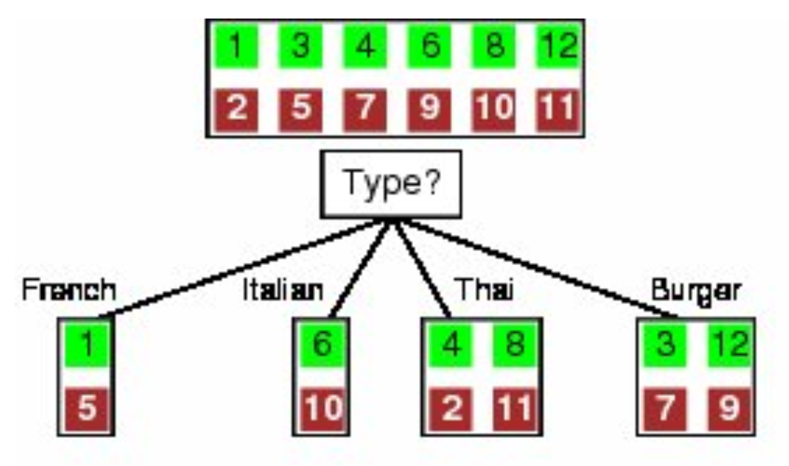

The quantity $H\left(Y|Italian\right)=$

$1$

$\frac{1}{2}$

$\frac{1}{4}$

1. 0

Ans

1. The size of a typical neuron is
   1. **4 microns** to **100 picometres**
   2. **4 microns** to **100 nanometres**
   3. **4 microns** to **100 micrometres**
   4. **4 microns** to **100 femtometres**

Ans

1. There are approximately ______________ neurons in the human brains
2. 10 billion
3. 10 million
4. 10 thousand
5. 10 trillion

Ans

1. In comparison to silicon logic gates, ***Neurons*** ____________
2. Have an equal speed of operation
3. Depends on the type of Neuron
4. Are Much faster
5. Are Much slower

Ans

1. The activation function employed in the ***McCulloch–Pitts model*** of a neural network is
2. Sigmoid function
3. ReLU function
4. Linear function
5. Threshold function

Ans

1. Consider the loss function of a single neuron neural net given as

$$L\left({\overline{w}}_{k}\right)=\frac{1}{2}{\left(y_{k}-ψ\left(\underset{u_{k}}{\underbrace{\sum_{j=1}^{m}{w_{kj}x_{j}}+b_{k}}}\right)\right)}^{2}$$

The corresponding update rule for the weight vector is

${\overline{w}}_{k}\left(n+1\right)={\overline{w}}_{k}\left(n\right)-η_{k}\left(y-ψ\left(u_{k}\left(n\right)\right)\right)ψ^{'}\left(u_{k}\left(n\right)\right)\overline{x}$

${\overline{w}}_{k}\left(n+1\right)={\overline{w}}_{k}\left(n\right)+η_{k}\left(y-ψ\left(u_{k}\left(n\right)\right)\right)\overline{x}$

${\overline{w}}_{k}\left(n+1\right)={\overline{w}}_{k}\left(n\right)+η_{k}\left(y-ψ\left(u_{k}\left(n\right)\right)\right)ψ^{'}\left(u_{k}\left(n\right)\right)\overline{x}$

${\overline{w}}_{k}\left(n+1\right)={\overline{w}}_{k}\left(n\right)+η_{k}ψ^{'}\left(u_{k}\left(n\right)\right)\overline{x}$

Ans

1. The ***ReLU function $f\left(x\right)$*** is defined as

$x$

$\left\{\begin{matrix}x & x≥0 \\ 0 & x<0\end{matrix}\right.$

$\frac{1}{1+e^{-x}}$

$\left\{\begin{matrix}1 & x≥0 \\ 0 & x<0\end{matrix}\right.$

Ans

1. In a two layer deep neural network, the gradient to update the weights of layer 1 during backpropagation is determined as

$\frac{∂}{∂W^{\left[1\right]}}L=\left({\left(W^{\left[2\right]}\right)}^{T}ϕ^{\left[2\right]}\right)×{\left({\overline{x}}^{\left[0\right]}\right)}^{T}$

$\frac{∂}{∂W^{\left[1\right]}}L=\left({\left(W^{\left[2\right]}\right)}^{T}ϕ^{\left[2\right]}⨀{\left(ψ^{\left[1\right]}\right)}^{'}\left({\overline{z}}^{\left[1\right]}\right)\right)×{\left({\overline{x}}^{\left[0\right]}\right)}^{T}$

$\frac{∂}{∂W^{\left[1\right]}}L=\left({\left(W^{\left[2\right]}\right)}^{T}ϕ^{\left[2\right]}⨀{\left(ψ^{\left[1\right]}\right)}^{'}\left({\overline{z}}^{\left[1\right]}\right)\right)×{\overline{x}}^{\left[0\right]}$

$\frac{∂}{∂W^{\left[1\right]}}L=\left({\left(W^{\left[2\right]}\right)}^{T}⨀{\left(ψ^{\left[1\right]}\right)}^{'}\left({\overline{z}}^{\left[1\right]}\right)\right)×{\left({\overline{x}}^{\left[0\right]}\right)}^{T}$

Ans

1. In a $K$ layer neural network, the size of the matrix $W^{\left[l\right]}$ for one of the inner layers is $m×n$, where $m,n$ are respectively
2. Number of neurons in layers $l,l-1$
3. Number of neurons in layers $l-1,l$
4. Number of neurons in layers $l$ and number of inputs in layer $0$
5. Number of neurons in layers $l$ and number of outputs in layer $K$

Ans

1. Convolutional neural nets are primarily suited for
2. Gaussian datasets
3. Purchase datasets
4. Random datasets
5. Images/ video datasets

Ans

1. Consider the simple image below

|  |  |  |  |
| --- | --- | --- | --- |
| 2 | 2 | 3 | 1 |
| 4 | 3 | 4 | 2 |
| 2 | 2 | 1 | 1 |
| 3 | 5 | 2 | 3 |

Max pooling with $2×2$ filters and stride 2 leads to

|  |  |
| --- | --- |
| 3 | 4 |
| 5 | 3 |

|  |  |
| --- | --- |
| 4 | 2 |
| 5 | 3 |

|  |  |
| --- | --- |
| 4 | 4 |
| 5 | 3 |

|  |  |
| --- | --- |
| 4 | 4 |
| 4 | 4 |

Ans

1. Consider the simple image below

|  |  |  |  |
| --- | --- | --- | --- |
| 2 | 2 | 3 | 1 |
| 4 | 3 | 4 | 2 |
| 2 | 2 | 1 | 1 |
| 3 | 5 | 2 | 3 |

Average pooling with $2×2$ filters and stride 2 leads to

|  |  |
| --- | --- |
| 2.75 | 2.25 |
| 3 | 1.75 |

|  |  |
| --- | --- |
| 2.75 | 2.5 |
| 3 | 1.75 |

|  |  |
| --- | --- |
| 2.75 | 2.5 |
| 3.25 | 1.75 |

|  |  |
| --- | --- |
| 2.75 | 2.5 |
| 3 | 1.5 |

Ans